EDUCATION: 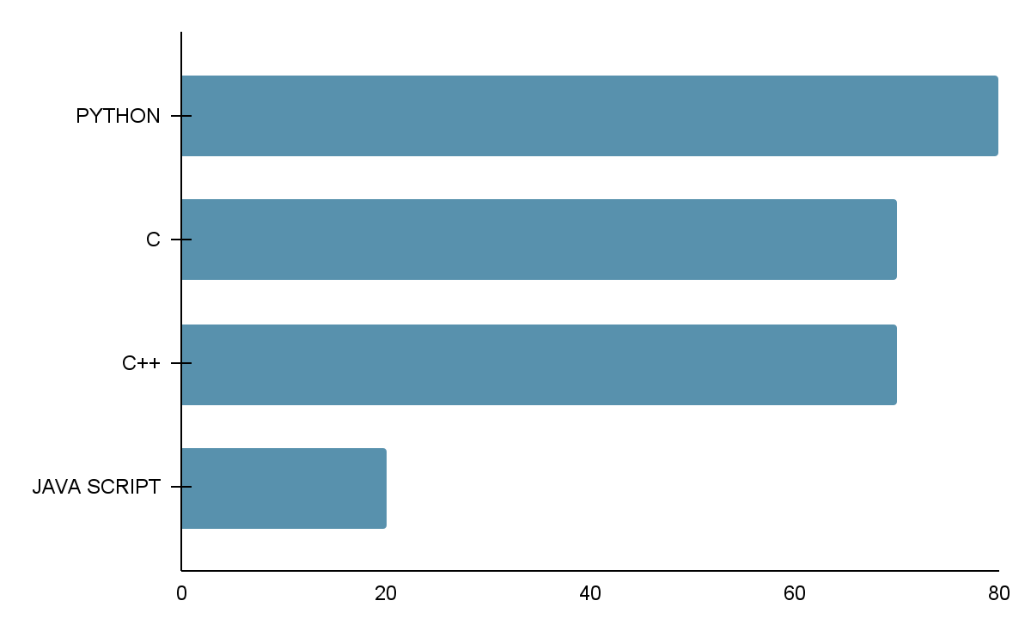

SAIRAM INSTITUTE OF TECHNOLOGY

B.E IN COMPUTER SCIENCE

WEST TAMBARAM, CHENNAI.

(BE in Computer science)

SKILLS:

* Python
* C
* HTML 5
* CSS
* Django
* Data Structures

COURSEWORK: EXPERIENCE: Fresher

* Artificial Intelligence Foundation
* Cloud Computing Foundation Course PROJECTS:

By Microsoft

* Introduction to Packet Tracker >E-commerce website using Django,
* Introduction to Cyber Security HTML, CSS, Java script
* Cyber Security Essentials by

CISCO

LINKS:

[www.linkedin.com/in/ragesh-b-007747212/](http://www.linkedin.com/in/ragesh-b-007747212/)

[ragesh0b/resume (github.com)](https://github.com/ragesh0b/resume)